

BUS USER INTERACTIVE NETWORK

CONCEPT DESIGN

**Project Code: BUIN**

**Document Code: BUIN_ Concept_Design_v1.0_EN**

**- Hanoi, 05/2015 -**

SIGNATURE PAGE

|  |  |  |
| --- | --- | --- |
| AUTHOR: | Bui Bich Phuong  Requirement Analysis | 20/05/2015 |
|  | Nguyen Le Tuan Cuong  Designer | 20/05/2015 |
| REVIEWERS: |  |  |
| Trinh Thi Tuyet Mai  Test Leader | 21/05/2015 |
|  |  |
| APPROVAL: | Nguyen Van Sang  Supervisor | 22/05/2015 |

Record of change

*A - Added M - Modified D - Deleted

|  |  |  |  |  |
| --- | --- | --- | --- | --- |
| Effective Date | Changed Items | A* M, D | Change Description | New Version |
| 20/05/2015 | Add new | A | Add this document | v1.0 |

TABLE OF CONTENTS

1 Sign in 5

2 Dashboard 5

3 Menu 7

4 Bus List 7

5 Bus Detail 9

6 Set Tracker 11

7 Bus Reminder 12

8 Add reminder 13

9 Add Reminder done 14

10 Path finder 16

11 Path Finder Result 18

12 Setting 20

13 Scan QR-code 22

14 Favorite 23

15 Place Search 25

16 Add Favorite Place 26

17 Account Info 27

# Sign in

Figure 1: Sign in

# Dashboard

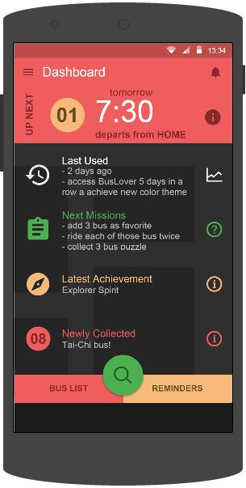

Figure 2: Dashboard

|  |  |  |  |  |  |  |  |
| --- | --- | --- | --- | --- | --- | --- | --- |
| **No** | **Field name** | **Field name in Vietnamese** | **Type** | **Require** | **Mandatory** | **Length** | **Description** |
| 1 |  |  | Button | Click | Y |  | User click on Skip button |
| 2 | Reminders | Nhắc nhở | Button | Click | Y |  | User click on REMINDERS button |
| 3 | Path Finder | Tìm đường | Button | Click | Y |  | User click on Path Finder button |
| 4 | Menu | Danh sách | Button | Click | Y |  | User click on Menu button |
| 5 | Notification | Thông báo | Button | Click | Y |  | User click on Notification button |

Table 1: Dashboard screen’s description

# Menu

# Bus List

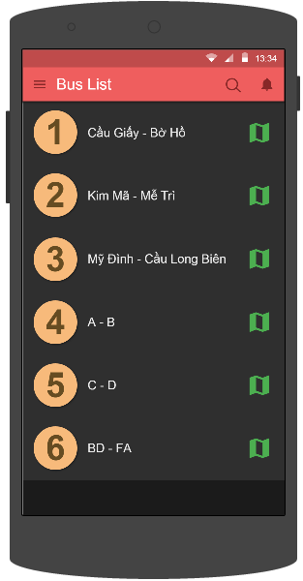

Figure 4: Bus List

|  |  |  |  |  |  |  |  |
| --- | --- | --- | --- | --- | --- | --- | --- |
| **No** | **Field name** | **Field name in Vietnamese** | **Type** | **Require** | **Mandatory** | **Length** | **Description** |
| 1 | Bus route | Tuyến xe buýt |  | Click | Y |  | User click on Skip button |
| 2 | Search | Tìm kiếm | Button | Click | Y |  | User click on Search button |
| 3 | Search Text | Khung tìm kiếm | Text | Text | Y | 255 | User input their key word they want to search with length less than 255 characters |
| 4 | Menu | Danh sách | Button | Click | Y |  | User click on Menu button |
| 5 | Notification | Thông báo | Button | Click | Y |  | User click on Notification button |

Figure 1: Sign in

Table 4: Bus List screen’s description

# Bus Detail

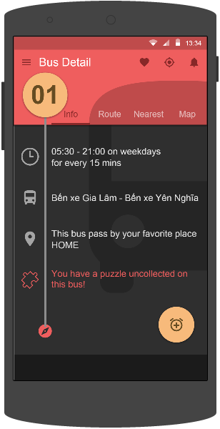

Figure 5: Bus Detail

|  |  |  |  |  |  |  |  |
| --- | --- | --- | --- | --- | --- | --- | --- |
| **No** | **Field name** | **Field name in Vietnamese** | **Type** | **Require** | **Mandatory** | **Length** | **Description** |
| 1 | Info | Thông tin | Button | Click | Y |  | User click on Info button |
| 2 | Route | Tuyến đường | Button | Click | Y |  | User click on Route button |
| 3 | Nearest | Nơi gần nhất | Button | Click | Y |  | User click on Nearest button |
| 4 | Map | Bản đồ | Button | Click | Y |  | User click on Map button |
| 5 | Favorite | Yêu thích | Button | Click | Y |  | User click on Favorite button |
| 6 | Tracker | Theo dõi | Button | Click | Y |  | User click on Track button |
| 7 | Menu | Danh sách | Button | Click | Y |  | User click on Menu button |
| 8 | Notification | Thông báo | Button | Click | Y |  | User click on Notification button |

Table 5: Bus Detail screen’s description

# Set Tracker

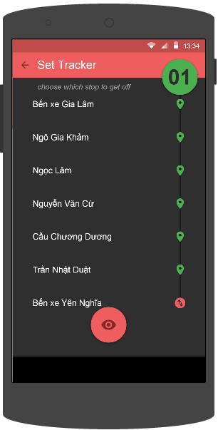

Figure 6: Set Tracker

|  |  |  |  |  |  |  |  |
| --- | --- | --- | --- | --- | --- | --- | --- |
| **No** | **Field name** | **Field name in Vietnamese** | **Type** | **Require** | **Mandatory** | **Length** | **Description** |
| 1 | Track | Theo dõi | Button | Click | Y |  | User click on Tracking button |
| 2 | Back | Quay lại | Button | Click | Y |  | User click on Back button to go back |

Table 6: Set Tracker screen’s description

# Bus Reminder

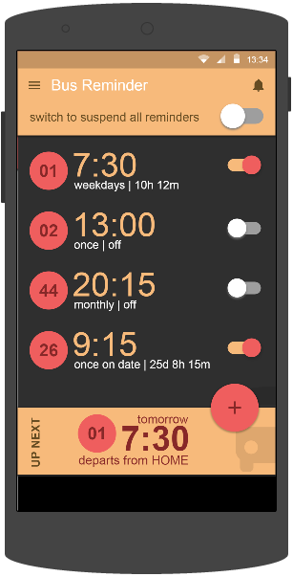

Figure 7: Bus Reminder

|  |  |  |  |  |  |  |  |
| --- | --- | --- | --- | --- | --- | --- | --- |
| **No** | **Field name** | **Field name in Vietnamese** | **Type** | **Require** | **Mandatory** | **Length** | **Description** |
| 1 | Add | Thêm | Button | Click | Y |  | User click on Add button |
| 2 | Menu | Danh sách | Button | Click | Y |  | User click on Menu button |
| 3 | Notification | Thông báo | Button | Click | Y |  | User click on Notification button |

Table 7: Bus Reminder screen’s description

# Add reminder

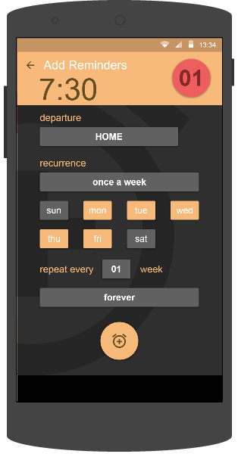

Figure 8: Add reminder

|  |  |  |  |  |  |  |  |
| --- | --- | --- | --- | --- | --- | --- | --- |
| **No** | **Field name** | **Field name in Vietnamese** | **Type** | **Require** | **Mandatory** | **Length** | **Description** |
| 1 | Clock | Báo thức | Button | Click | Y |  | User click on Clock button |
| 2 | Back | Quay lại | Button | Click | Y |  | User click on Back button to go back |

Table 8: Add Reminder screen’s description

# Add Reminder done

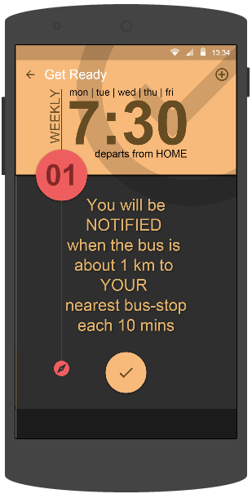

Figure 9: Add Reminder done

|  |  |  |  |  |  |  |  |
| --- | --- | --- | --- | --- | --- | --- | --- |
| **No** | **Field name** | **Field name in Vietnamese** | **Type** | **Require** | **Mandatory** | **Length** | **Description** |
| 1 | Add | Thêm nhắc nhở | Button | Click | Y |  | User click on Add button |
| 2 | Back | Quay lại | Button | Click | Y |  | User click on Back button to go back |
| 3 | OK | Hoàn thành | Button | Click | Y |  | User click on OK button to be done |

Table 9: Add Reminder done screen’s description

# Path finder

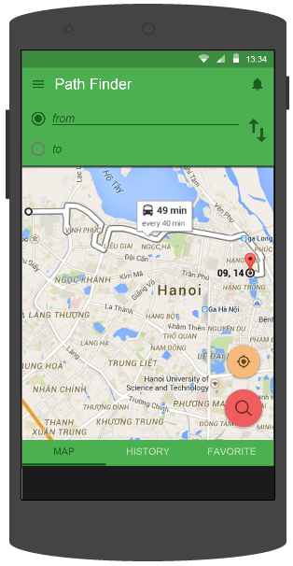

Figure 10: Path Finder

|  |  |  |  |  |  |  |  |
| --- | --- | --- | --- | --- | --- | --- | --- |
| **No** | **Field name** | **Field name in Vietnamese** | **Type** | **Require** | **Mandatory** | **Length** | **Description** |
| 1 | From | Từ | Text | Text | Y | 255 | User input their position or the place they start to go with less than 255 characters. |
| 2 | To | Đến | Text | Text | Y | 255 | User input the place they want to go with less than 255 characters. |
| 3 | Reverse | Đảo chiều | Button | Click | Y |  | User click on Reverse button |
| 4 | Search | Tìm kiếm | Button | Click | Y |  | User click on Search button |
| 5 | Track | Theo dõi | Button | Click | Y |  | User click on Track button |
| 6 | Map | Bản đồ | Button | Click | Y |  | User click on Map button |
| 7 | History | Lịch sử | Button | Click | Y |  | User click on History button |
| 8 | Favorite | Yêu thích | Button | Click | Y |  | User click on Favorite button |
| 9 | Menu | Danh sách | Button | Click | Y |  | User click on Menu button |
| 10 | Notification | Thông báo | Button | Click | Y |  | User click on Notification button |

Table 10: Path Finder screen’s description

# Path Finder Result

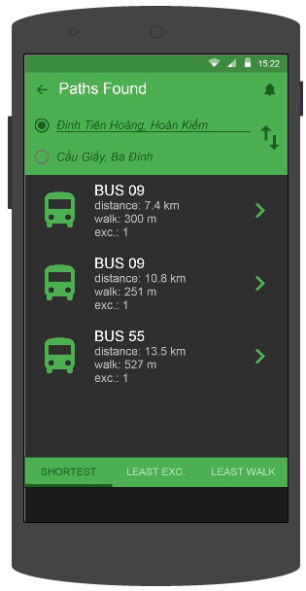

Figure 11: Path Finder Result

|  |  |  |  |  |  |  |  |
| --- | --- | --- | --- | --- | --- | --- | --- |
| **No** | **Field name** | **Field name in Vietnamese** | **Type** | **Require** | **Mandatory** | **Length** | **Description** |
| 1 | Reverse | Đảo chiều | Button | Click | Y |  | User click on Reverse button |
| 2 | Shortest | Quãng đường ngắn nhất | Button | Click | Y |  | User click on Shortest button |
| 3 | Least Exc | Chuyển tuyến ít nhất | Button | Click | Y |  | User click on Least Exc button |
| 4 | Least Walk | Đi bộ ít nhất | Button | Click | Y |  | User click on Least Walk button |
| 5 | Menu | Danh sách | Button | Click | Y |  | User click on Menu button |
| 6 | Notification | Thông báo | Button | Click | Y |  | User click on Notification button |

Table 11: Path Finder Result screen’s description

# Setting

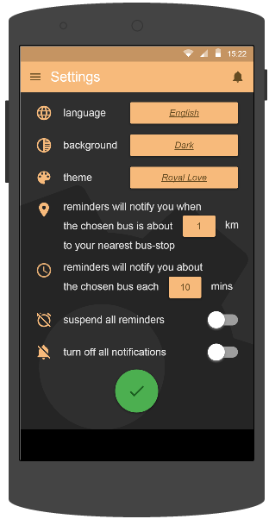

Figure 12: Setting

|  |  |  |  |  |  |  |  |
| --- | --- | --- | --- | --- | --- | --- | --- |
| **No** | **Field name** | **Field name in Vietnamese** | **Type** | **Require** | **Mandatory** | **Length** | **Description** |
| 1 | Language | Ngôn ngữ | Dropdown | Click | Y |  | User click to choose language |
| 2 | Background | Nền | Dropdown | Click | Y |  | User click to choose background |
| 3 | Theme | Giao diện | Dropdown | Click | Y |  | User click to choose theme |
| 4 | Reminder will notify you when the chosen bus is about X km to your nearest bus-stop | Nhắc nhở khi xe buýt được chọn ở cách điểm dừng xe buýt gần nhất với bạn là X km | Button | Click | Y |  | User click choose the distance they want |
| 5 | Reminder will notify you when the chosen bus each X minutes | Nhắc nhở về xe buýt được chọn mỗi X phút | Button | Click | Y |  | User click to choose the time they want |
| 6 | Suspend all reminders | Tắt tất cả nhắc nhở | Switch | Click | Y |  | User click on Suspend all reminders button |
| 7 | Turn off all notification | Tắt tất cả thông báo | Switch | Click | Y |  | User click on Turn off all notification button |
| 8 | OK | Hoàn tất | Button | Click | Y |  | User click on OK button |
| 9 | Menu | Danh sách | Button | Click | Y |  | User click on Menu button |
| 10 | Notification | Thông báo | Button | Click | Y |  | User click on Notification button |

Table 12: Setting screen’s description

# Scan QR-code

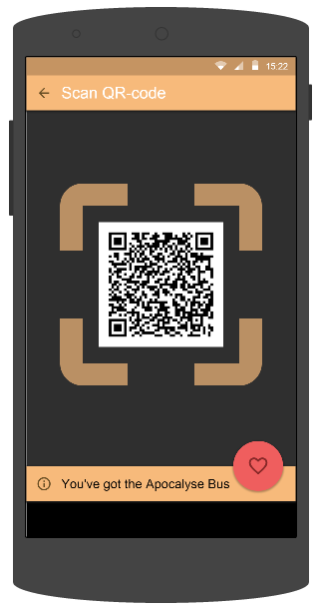

Figure 13: Scan QR-code

|  |  |  |  |  |  |  |  |
| --- | --- | --- | --- | --- | --- | --- | --- |
| **No** | **Field name** | **Field name in Vietnamese** | **Type** | **Require** | **Mandatory** | **Length** | **Description** |
| 1 | Favorite | Yêu thích | Button | Click | Y |  | User click on Favorite button |
| 2 | Back | Quay lại | Button | Click | Y |  | User click on Back button to go back |

Table 13: Scan QR-code screen’s description

# Favorite

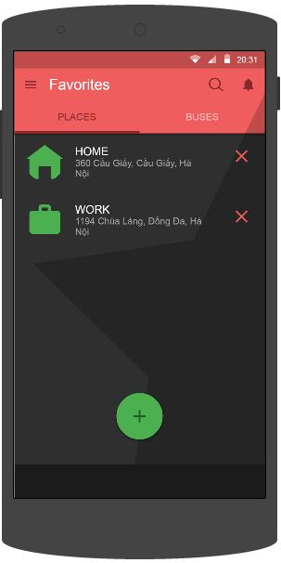

Figure 14: Favorite

|  |  |  |  |  |  |  |  |
| --- | --- | --- | --- | --- | --- | --- | --- |
| **No** | **Field name** | **Field name in Vietnamese** | **Type** | **Require** | **Mandatory** | **Length** | **Description** |
| 1 | Add | Thêm | Button | Click | Y |  | User click on Add button |
| 2 | Delete | Xóa | Button | Click | Y |  | User click on Delete button |
| 3 | Search | Tìm kiếm | Button | Click | Y |  | User click on Search button |
| 4 | Search Text | Khung tìm kiếm | Text | Text | Y | 255 | User input their key word they want to search with length less than 255 characters |
| 5 | Menu | Danh sách | Button | Click | Y |  | User click on Menu button |
| 6 | Notification | Thông báo | Button | Click | Y |  | User click on Notification button |

Table 14: Favorite screen’s description

# Place Search

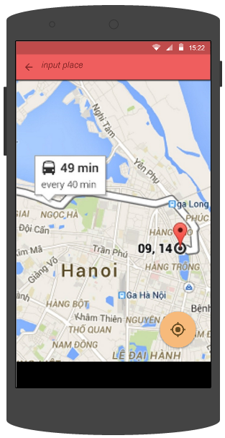

Figure 15: Place Search

|  |  |  |  |  |  |  |  |
| --- | --- | --- | --- | --- | --- | --- | --- |
| **No** | **Field name** | **Field name in Vietnamese** | **Type** | **Require** | **Mandatory** | **Length** | **Des** **cription** |
| 1 | Input place | Nhập địa điểm | Text | Text | Y | 255 | User input the place they want to search with the length less than 255 characters |
| 2 | Back | Quay lại | Button | Click | Y |  | User click on Back button to go back |
| 3 | Current location | Vị trí hiện tại | Button | Click | Y |  | User click on Current location button |

Table 15: Place Search screen’s description

# Add Favorite Place

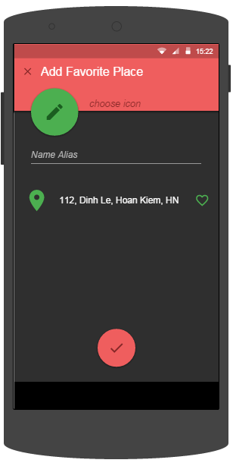

Figure 16: Add Favorite Place

|  |  |  |  |  |  |  |  |
| --- | --- | --- | --- | --- | --- | --- | --- |
| **No** | **Field name** | **Field name in Vietnamese** | **Type** | **Require** | **Mandatory** | **Length** | **Description** |
| 1 | Favorite | Yêu thích | Button | Click | Y |  | User click on Favorite button |
| 2 | OK | Hoàn tất | Button | Click | Y |  | User click on OK button |

Table 16: Add Favorite Place screen’s description

# Account Info

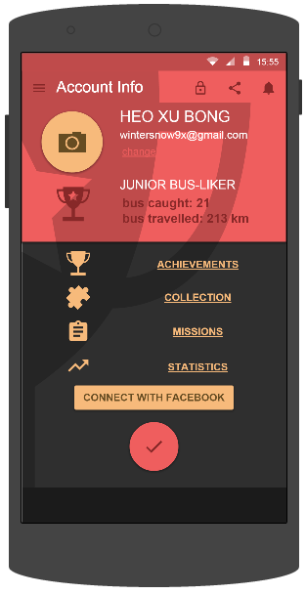

Figure 17: Account Info

|  |  |  |  |  |  |  |  |
| --- | --- | --- | --- | --- | --- | --- | --- |
| **No** | **Field name** | **Field name in Vietnamese** | **Type** | **Require** | **Mandatory** | **Length** | **Description** |
| 1 | Lock | Khóa | Button | Click | Y |  | User click on Lock button |
| 2 | Share | Chia sẻ | Button | Click | Y |  | User click on Share button |
| 3 | Achievement | Huy chương | Button | Click | Y |  | User click on Achievement button |
| 4 | Collection | Sưu tập | Button | Click | Y |  | User click on Collection button |
| 5 | Missions | Nhiệm vụ | Button | Click | Y |  | User click on Missions button |
| 6 | Statistics | Thống kê | Button | Click | Y |  | User click on Statistics button |
| 7 | Connect with facebook | Liên kết mạng xã hội | Button | Click | Y |  | User click on Connect with facebook button |
| 8 | OK | Hoàn tất | Button | Click | Y |  | User click on OK button |
| 9 | Menu | Danh sách | Button | Click | Y |  | User click on Menu button |
| 10 | Notification | Thông báo | Button | Click | Y |  | User click on Notification button |

Table 17: Account Info screen’s description